**Coolest Cooler**

Weight: 7oz  
Size: W3.4xD2.5xH2.5in  
Material: PVC  
Lifespan: 5 years  
Funding: $14M  
Units shipped: 40,000  
Retail Price: $185

An overspecced combination cooler / speaker / blender that failed to deliver so thoroughly it was investigated as fraud.

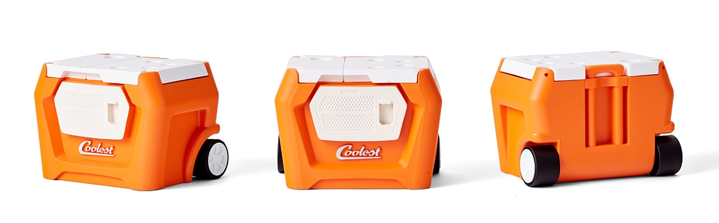

THE STORY

Poster child for the pitfalls of crowdfunding, the Coolest Cooler was an all-in-one outdoor event station that combined a cooler, speaker, blender, and general-purpose battery. At a bargain $185 pre-order price, the Coolest Cooler merged design solutionism with dad-core to create a total package that seemed too-good-to-be-true. Unsurprisingly in retrospect, it was.

Created by Ryan Grepper, the Coolest Cooler failed its Kickstarter campaign in 2013, then retooled and relaunched in 2014 with the help of numerous tweaks that smell like a marketing company’s involvement. It became the highest-funded product in Kickstarter’s history at that point, raising just over $13 million.

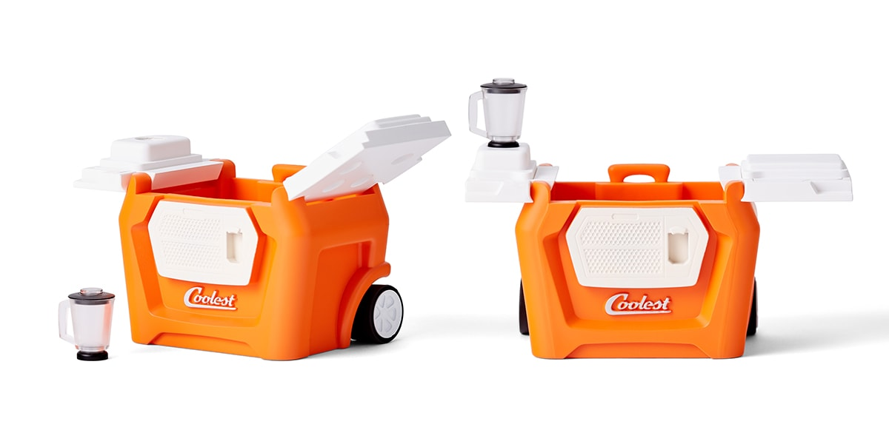

The Coolest Cooler was woefully unprepared to meet the challenge of its own success. Far in over its head, committed to a complex design without the funding to cover it nor the proper margins to handle the logistics of its Chinese production setup, the Coolest Cooler stalled after fulfilling only a fraction of its Kickstarter orders. It then, in a Hail Mary move to grab revenue that simultaneously spit directly in its backers’ faces, began selling Coolers at retail before it fulfilled its preorders, while also attempting to upcharge preorder holders for expedited shipping. Astute observers will recognize that this is essentially the same action as holding the pre-ordered Coolers for ransom.

In 2016, the Oregon Department of Justice opened investigations into Coolest Cooler for unlawful trade practices. A year later, Cooler settled with the Oregon DOJ and ultimately committed to refunding its jilted backers a whopping $20 each. Because the company was effectively bankrupt at this point, it is unclear whether backers received this money.

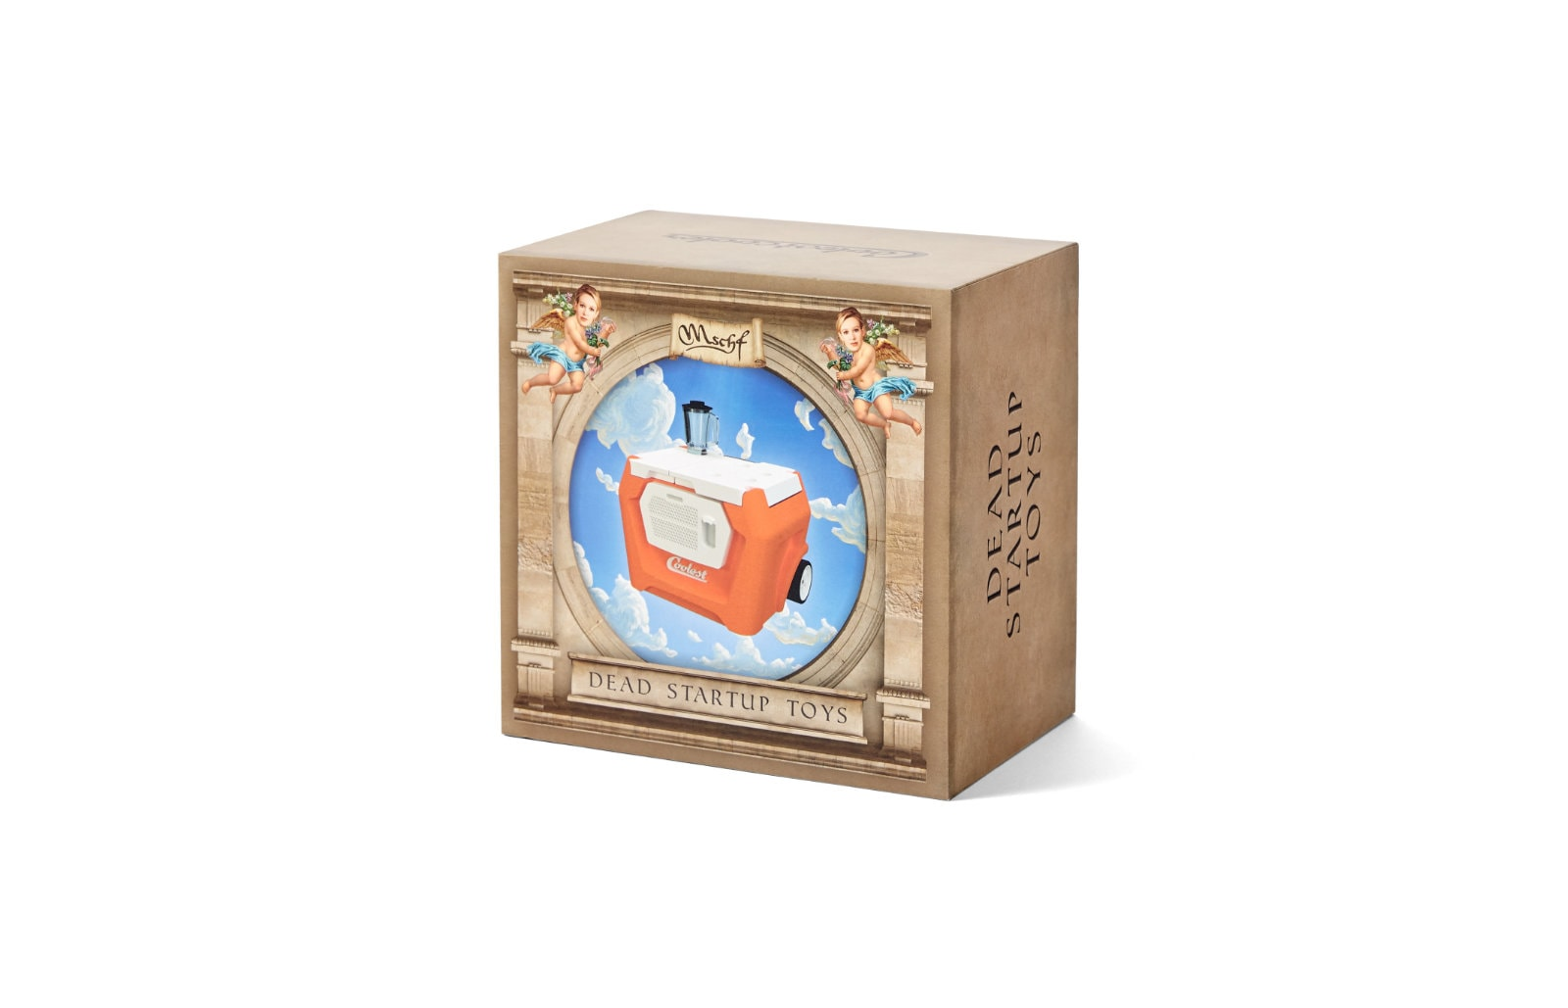

The Coolest Cooler died alone, after alienating most of the people who once loved it. Crowdfunding allowed the American consumer public a tiny tantalizing taste of the VC experience by gambling on non-existent products. The Coolest Cooler stands as a cautionary tale for crowdfunding as a whole, and possibly the landmark event in the crowdfunding paradigm’s fall from grace. For that at least we salute it in memoriam.

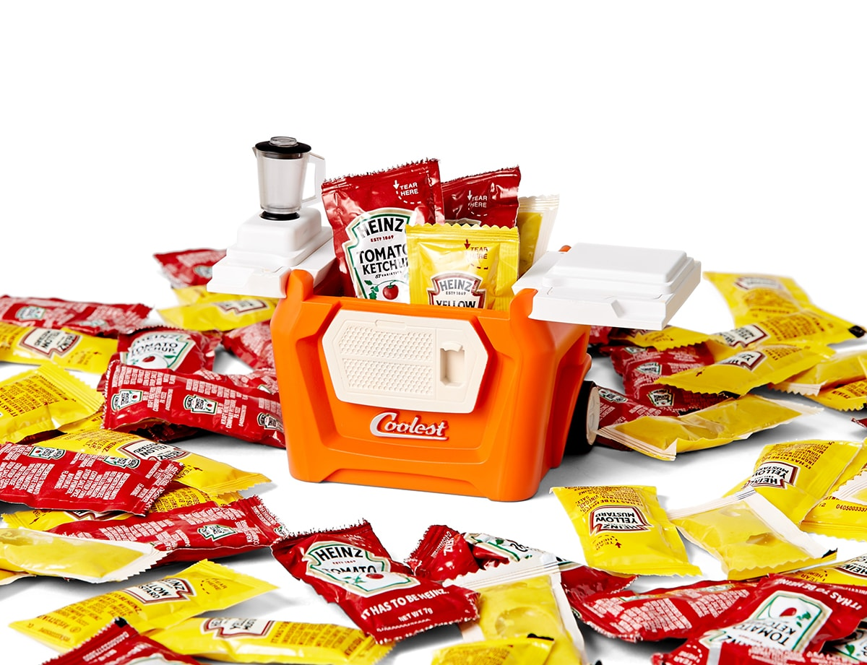

Add to Cart$39.99Back to overview

# **Crowdfunding disaster Coolest Cooler is shutting down and blaming tariffs for its downfall *RIP to Coolest Cooler***

By [Ashley Carman](https://www.theverge.com/authors/ashley-carman)[@ashleyrcarman](https://www.twitter.com/ashleyrcarman)  Dec 9, 2019, 3:41pm EST

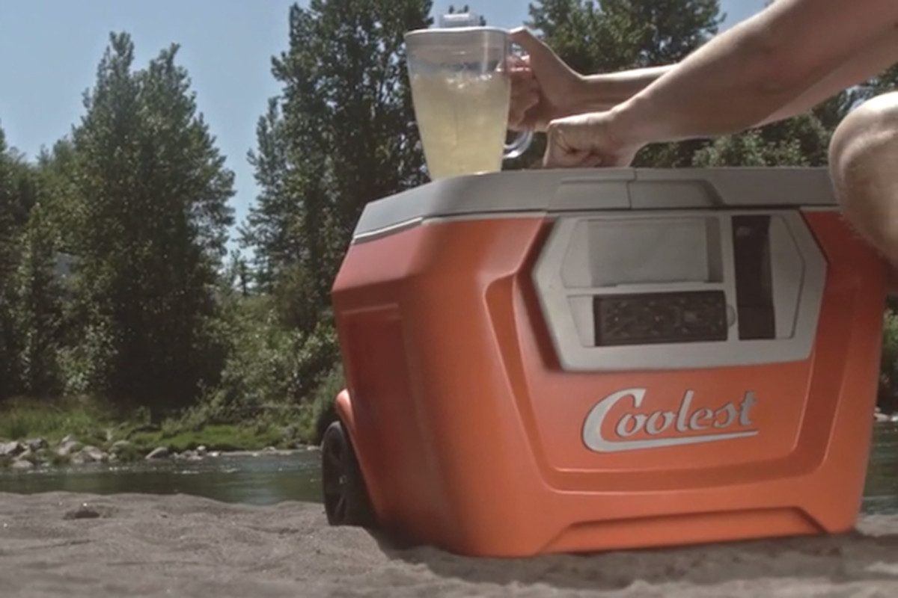

The company behind [the Coolest Cooler](https://www.theverge.com/2016/4/13/11424924/coolest-cooler-kickstarter-disaster-delays), widely known as one of the biggest Kickstarter failures, is officially going out of business. An update sent to backers from the company’s CEO Ryan Grepper this weekend says the company is ending operations, and tariffs are to blame. Grepper says a tariff increase on Chinese imports to 25 percent affected the “entire Coolest product line.”

“It was devastating to our business, and I know it was felt by many of you in one way or another as consumers and thousands of small businesses everywhere,” he writes.

While the tariffs are certainly real, it’s odd for this update to arrive five years after the Coolest Cooler originally [showed up on Kickstarter](https://www.kickstarter.com/projects/ryangrepper/coolest-cooler-21st-century-cooler-thats-actually/description). The campaign raised more than $13 million in 2014 to build a high-tech cooler with a built-in blender, and it’s still the second-highest grossing project on the platform, after the Pebble Time smartwatch. The team ultimately put the cooler up for sale on Amazon before it even shipped all its owed product to backers. In the end, it shipped roughly two-thirds of the 60,000 coolers it owed people, the company said in a project update in March 2018.

“There’s always a risk in creating something new, and some projects won’t end up working out,” Kickstarter said in a statement. “In this case, unfortunately, 1/3 of the backers won’t receive the reward they were promised. We’ve worked hard to make it clear that Kickstarter is not a store. And in the five years since this project was funded, we’ve taken steps to help creators be more transparent with backers, and to better understand what it will take to bring their project to life.”

Coolest settled with Oregon’s Department of Justice in 2017. The agreement involves paying backers $20 per cooler that wasn’t received. It seems possible that backers might not receive their $20, particularly if the company is out of cash. The Oregon DOJ says the company has until 2020 to pay the remaining consumers.

***Update 12/9, 5:23 PM ET:****Updated to include the Oregon DOJ comment.*

Coolest Cooler

|  |
| --- |
| **Coolest Cooler** |
|  |

|  |  |
| --- | --- |
| **Developer** | Ryan Grepper |
| **Release date** | 24 July 2015[[1]](https://en.wikipedia.org/wiki/Coolest_Cooler#cite_note-kickstarter-1) |
| **Discontinued** | 06 December 2019 |
| **Sound** | [Bluetooth](https://en.wikipedia.org/wiki/Bluetooth) water-resistant speaker[[1]](https://en.wikipedia.org/wiki/Coolest_Cooler#cite_note-kickstarter-1) |
| **Input** | 2x [USB](https://en.wikipedia.org/wiki/USB) charging port (5 [volts](https://en.wikipedia.org/wiki/Volt), 1 [amp](https://en.wikipedia.org/wiki/Ampere) & 2.1 [amp](https://en.wikipedia.org/wiki/Ampere))[[1]](https://en.wikipedia.org/wiki/Coolest_Cooler#cite_note-kickstarter-1) |
| **Power** | 20[V](https://en.wikipedia.org/wiki/Volt) [Rechargeable](https://en.wikipedia.org/wiki/Rechargeable) [lithium ion battery](https://en.wikipedia.org/wiki/Lithium_ion_battery) |

The **Coolest Cooler** was a multi-function [cooler](https://en.wikipedia.org/wiki/Cooler) that was initially funded through the [crowdfunding](https://en.wikipedia.org/wiki/Crowdfunding) website [Kickstarter](https://en.wikipedia.org/wiki/Kickstarter). In the summer of 2014, Ryan Grepper raised over $13 million, making it the most funded Kickstarter campaign of 2014.[[2]](https://en.wikipedia.org/wiki/Coolest_Cooler#cite_note-biggestever-2) Crowdfunders were offered the product at a discounted rate but eventually due to corporate failure not all backers received a product.

In December 2019, CEO and founder Ryan Grepper announced that the company was closing, having never delivered coolers to an estimated 20,000 of the original backers. This makes Coolest Coolers one of the most disastrous campaigns ever on Kickstarter.[[3]](https://en.wikipedia.org/wiki/Coolest_Cooler#cite_note-3)

Crowdfunding

Grepper was a product developer from Portland, Oregon. He first tried to raise funding for the product in November 2013 but fell short of the $125,000 goal and failed to secure any funding. He launched a second campaign on July 8, 2014, and critics attribute the success of the second Kickstarter campaign to the timing.[[4]](https://en.wikipedia.org/wiki/Coolest_Cooler#cite_note-4) The Coolest received extensive press coverage when it topped the funding goals of the [Pebble watch](https://en.wikipedia.org/wiki/Pebble_watch), and ended the campaign in August with $13,285,226 and 62,642 backers, making it the most funded Kickstarter campaign of 2014.[[2]](https://en.wikipedia.org/wiki/Coolest_Cooler#cite_note-biggestever-2)

Background

Grepper designed the Coolest, initially using a weed whacker[[5]](https://en.wikipedia.org/wiki/Coolest_Cooler#cite_note-5) to build a portable gas-powered blender. He subsequently re-engineered a cooler with a car stereo to bring to an Independence Day beach party for friends. Grepper has said that improvements in technology and the reduced size of components made him realize that the multi-function cooler could be engineered as a consumer product and developed a prototype using 3D printing technology.[[6]](https://en.wikipedia.org/wiki/Coolest_Cooler#cite_note-6)

Features

It includes an ice-crushing [blender](https://en.wikipedia.org/wiki/Blender), a [Bluetooth](https://en.wikipedia.org/wiki/Bluetooth) water-resistant speaker, a [USB](https://en.wikipedia.org/wiki/USB) charging port, [LED lamps](https://en.wikipedia.org/wiki/LED_lamps), a bottle opener with magnetic cap catch, plates, knife, corkscrew and a removable divider that can also be used as a cutting board.[[1]](https://en.wikipedia.org/wiki/Coolest_Cooler#cite_note-kickstarter-1) The split lid design is made with steel hinges and includes cup-holders.

The cooler's hexagonal shape has a 55+ quart capacity.[[7]](https://en.wikipedia.org/wiki/Coolest_Cooler#cite_note-7) The cooler is powered by a rechargeable [lithium-ion battery](https://en.wikipedia.org/wiki/Lithium-ion_battery) and the removable Bluetooth speaker is also rechargeable and can be paired with a second speaker up to 30 feet away.

Development and delays

When Grepper launched the Kickstarter campaign for the Coolest, the company planned to deliver to backers their Coolest reward in February 2015. The success of the campaign significantly increased demand, and they were being made in China.[[8]](https://en.wikipedia.org/wiki/Coolest_Cooler#cite_note-8) Due to the change in quantity, complexity of shipping, logistics and certification processes, production has taken longer than expected. In February 2015, the company announced a postponement to July 2015.[[9]](https://en.wikipedia.org/wiki/Coolest_Cooler#cite_note-9) Grepper cited improvements and upgrades[[10]](https://en.wikipedia.org/wiki/Coolest_Cooler#cite_note-10) as partial reasons for the delay in a post on the company's blog.[[11]](https://en.wikipedia.org/wiki/Coolest_Cooler#cite_note-11)

The first units were shipped in July 2015, and by November 2015 tens of thousands of backers received their cooler. The company estimated they would clear the large backlog by April 2016.[[12]](https://en.wikipedia.org/wiki/Coolest_Cooler#cite_note-12) During a live-streamed web conference in March 2016, Grepper admitted production had stopped, and he was seeking an additional $15 million, with one third of this to be put towards meeting 36,000 outstanding orders from backers.[[13]](https://en.wikipedia.org/wiki/Coolest_Cooler#cite_note-13) In April 2016, Grepper added an option to spend $97 in order to get expedited shipping on the backer's delayed coolers.[[14]](https://en.wikipedia.org/wiki/Coolest_Cooler#cite_note-14) In May 2016, it was reported that more than 10,000 backers had supported this option and production had resumed in China.[[15]](https://en.wikipedia.org/wiki/Coolest_Cooler#cite_note-restarting-15) The company said it would fund delivery of the remaining 26,000 backer rewards from profits from retail sales.

In September 2016, after receiving 315 consumer complaints in the past year, the Oregon Department of Justice confirmed that it was investigating Coolest Cooler[[16]](https://en.wikipedia.org/wiki/Coolest_Cooler#cite_note-justice-16) for possible violations of the state's Unlawful Trade Practices Act.

As of February 2017, some backers were still waiting, but Coolest claimed to use funds from sales on their website to deliver coolers to backers at the rate of 30-50 per week.[[17]](https://en.wikipedia.org/wiki/Coolest_Cooler#cite_note-still_waiting-17)

In June 2017, Coolest LLC entered into an agreement with the Oregon Department of Justice that specified the plan for fulfilling remaining Kickstarter Backer rewards.[[18]](https://en.wikipedia.org/wiki/Coolest_Cooler#cite_note-18)

In December 2019, Grepper and Coolest, LLC, announced they were ceasing operations and would be complying with the Oregon Department of Justice agreement.[[19]](https://en.wikipedia.org/wiki/Coolest_Cooler#cite_note-oreg-2019dec-19)[[20]](https://en.wikipedia.org/wiki/Coolest_Cooler#cite_note-20)[[21]](https://en.wikipedia.org/wiki/Coolest_Cooler#cite_note-21)

References

* 1. ^ [Jump up to:](https://en.wikipedia.org/wiki/Coolest_Cooler#cite_ref-kickstarter_1-0)***[a](https://en.wikipedia.org/wiki/Coolest_Cooler#cite_ref-kickstarter_1-0)*** ***[b](https://en.wikipedia.org/wiki/Coolest_Cooler#cite_ref-kickstarter_1-1)*** ***[c](https://en.wikipedia.org/wiki/Coolest_Cooler#cite_ref-kickstarter_1-2)*** ***[d](https://en.wikipedia.org/wiki/Coolest_Cooler#cite_ref-kickstarter_1-3)*** *["COOLEST COOLER: 21st Century Cooler that's Actually Cooler"](https://www.kickstarter.com/projects/ryangrepper/coolest-cooler-21st-century-cooler-thats-actually). Kickstarter. Retrieved 18 March 2016.*
  2. ^ [Jump up to:](https://en.wikipedia.org/wiki/Coolest_Cooler#cite_ref-biggestever_2-0)***[a](https://en.wikipedia.org/wiki/Coolest_Cooler#cite_ref-biggestever_2-0)*** ***[b](https://en.wikipedia.org/wiki/Coolest_Cooler#cite_ref-biggestever_2-1)*** *Smith, Chris (27 August 2014). ["Move over, Pebble: The Coolest Cooler is now the biggest Kickstarter campaign ever"](https://bgr.com/general/coolest-cooler-kickstarter-funding-record-3644945/). [Boy Genius Report](https://en.wikipedia.org/wiki/Boy_Genius_Report). Retrieved June 22, 2021.*
  3. **[^](https://en.wikipedia.org/wiki/Coolest_Cooler#cite_ref-3)** *["Coolest Cooler bankrupt with 20,000 Kickstarter pledges unfulfilled"](https://www.geeky-gadgets.com/coolest-cooler-bankrupt-10-12-2019/). www.geeky-gadgets.com. December 10, 2019. Retrieved June 22, 2021.*
  4. **[^](https://en.wikipedia.org/wiki/Coolest_Cooler#cite_ref-4)** *Jeffries, Adrianne (27 August 2014). ["The biggest Kickstarter ever failed the first time around"](https://www.theverge.com/2014/8/27/6074101/the-biggest-kickstarter-ever-failed-the-first-time-around). [The Verge](https://en.wikipedia.org/wiki/The_Verge). Vox Media. Retrieved 18 March 2016.*
  5. **[^](https://en.wikipedia.org/wiki/Coolest_Cooler#cite_ref-5)** *Volastro, Anthony; Rosenbaum, Eric (26 August 2014). ["A new king of Kickstarter is crowned!"](https://www.cnbc.com/2014/08/26/a-new-king-of-kickstarter-about-to-be-crowned.html). [CNBC](https://en.wikipedia.org/wiki/CNBC). Retrieved 12 May 2018.*
  6. **[^](https://en.wikipedia.org/wiki/Coolest_Cooler#cite_ref-6)** *["The Coolest Cooler"](https://fathommfg.com/blog/coolestcooler). fathommfg.com. January 8, 2021. Retrieved June 22, 2021.*
  7. **[^](https://en.wikipedia.org/wiki/Coolest_Cooler#cite_ref-7)** *["The 'Coolest' cooler - 60 quarts of style with a built in blender, music and way, way more"](https://web.archive.org/web/20190508062551/https:/coolest.com/). www.coolest.com. Archived from [the original](http://www.coolest.com/) on 22 June 2021.*
  8. **[^](https://en.wikipedia.org/wiki/Coolest_Cooler#cite_ref-8)** *["Coolest Cooler Partners with Dragon Innovation on Production"](http://www.crowdfundinsider.com/2014/11/55146-coolest-cooler-partners-dragon-innovation-production/). Crowdfund Insider.*
  9. **[^](https://en.wikipedia.org/wiki/Coolest_Cooler#cite_ref-9)** *Taylor Soper. ["'Coolest Cooler' shipments delayed in setback for record-breaking $13.3M Kickstarter campaign - GeekWire"](http://www.geekwire.com/2014/coolest-cooler-shipments-delayed-setback-record-breaking-9-2m-kickstarter-campaign/). GeekWire.*
  10. **[^](https://en.wikipedia.org/wiki/Coolest_Cooler#cite_ref-10)** *["Coolest Cooler Selects Manufacturer, Upgrades Battery"](http://www.crowdfundinsider.com/2014/10/52501-coolest-cooler-selects-manufacturer-upgrades-battery/). Crowdfund Insider.*
  11. **[^](https://en.wikipedia.org/wiki/Coolest_Cooler#cite_ref-11)** *["COOLEST COOLER: 21st Century Cooler that's Actually Cooler by Ryan Grepper — Kickstarter"](https://www.kickstarter.com/projects/ryangrepper/coolest-cooler-21st-century-cooler-thats-actually/posts/1076891). Kickstarter.*
  12. **[^](https://en.wikipedia.org/wiki/Coolest_Cooler#cite_ref-12)** *Hern, Alex (19 November 2015). ["Trouble on Kickstarter as two massive projects hit the rocks"](https://www.theguardian.com/technology/2015/nov/19/trouble-kickstarter-massive-projects-hit-rocks-coolest-zano). The Guardian. Retrieved 20 November 2015.*
  13. **[^](https://en.wikipedia.org/wiki/Coolest_Cooler#cite_ref-13)** *Marum, Anna (8 March 2016). ["Coolest Cooler needs another $15 million, creator says"](http://www.oregonlive.com/window-shop/index.ssf/2016/03/coolest_cooler_15_million.html). [The Oregonian](https://en.wikipedia.org/wiki/The_Oregonian). Retrieved 18 March 2016.*
  14. **[^](https://en.wikipedia.org/wiki/Coolest_Cooler#cite_ref-14)** *Micah Singleton (13 April 2016). ["$13 million Kickstarter project for a cooler continues to be a disaster"](https://www.theverge.com/2016/4/13/11424924/coolest-cooler-kickstarter-disaster-delays). The Verge. Vox Media.*
  15. **[^](https://en.wikipedia.org/wiki/Coolest_Cooler#cite_ref-restarting_15-0)** *Marum, Anna (May 6, 2016). ["Coolest Cooler is restarting production"](http://www.oregonlive.com/window-shop/index.ssf/2016/05/coolest_cooler_restarts_production.html). [The Oregonian](https://en.wikipedia.org/wiki/The_Oregonian). Retrieved July 21, 2020.*
  16. **[^](https://en.wikipedia.org/wiki/Coolest_Cooler#cite_ref-justice_16-0)** *Marum, Anna (30 September 2016). ["State launches Coolest Cooler investigation"](http://www.oregonlive.com/window-shop/index.ssf/2016/09/coolest_cooler_investigation.html). [The Oregonian](https://en.wikipedia.org/wiki/The_Oregonian). Retrieved 1 December 2016.*
  17. **[^](https://en.wikipedia.org/wiki/Coolest_Cooler#cite_ref-still_waiting_17-0)** *Schlosser, Kurt (10 February 2017). ["Coolest Cooler delivers new update as deliveries trickle out for still-waiting Kickstarter backers"](http://www.geekwire.com/2017/coolest-cooler-delivers-new-update-deliveries-trickle-still-waiting-kickstarter-backers/). [Geek Wire](https://en.wikipedia.org/wiki/Geek_Wire). Retrieved 4 April 2017.*
  18. **[^](https://en.wikipedia.org/wiki/Coolest_Cooler#cite_ref-18)** *Rogoway, Mike (June 27, 2017). ["Coolest Cooler settles with Oregon Department of Justice"](https://www.oregonlive.com/business/2017/06/coolest_cooler_settles_with_or.html). The Oregonian.*
  19. **[^](https://en.wikipedia.org/wiki/Coolest_Cooler#cite_ref-oreg-2019dec_19-0)** *Rogoway, Mike (December 8, 2019) [online date December 7]. ["Coolest Cooler calls it quits, will refund backers $20"](https://www.oregonlive.com/business/2019/12/coolest-cooler-calls-it-quits-admits-thousands-of-backers-will-never-get-their-coolers.html). The Sunday Oregonian. p. A15. Retrieved July 21, 2020.*
  20. **[^](https://en.wikipedia.org/wiki/Coolest_Cooler#cite_ref-20)** *Carman, Ashley. ["Crowdfunding disaster Coolest Cooler is shutting down and blaming tariffs for its downfall. RIP to Coolest Cooler"](https://www.theverge.com/2019/12/9/21003445/coolest-cooler-update-business-tariffs-kickstarter). The Verge. Retrieved June 10, 2021.*

1. **[^](https://en.wikipedia.org/wiki/Coolest_Cooler#cite_ref-21)** *Grepper, Ryan (6 December 2019). ["Coolest Announces Shutdown"](https://docs.google.com/document/d/e/2PACX-1vQjDWG6N9lBnrB1Wh-VDYvlvfVyON7pz7QQfiLdlWZF9mO7LvyKkF_-I3Cfmp6GLGry-UM-wRnD8xYN/pub). backer email official cache. Retrieved June 1, 2020.*